**Cancelling Sent Friend Requests on FB**

**1. Go to this mobile version of Facebook:**

<https://m.facebook.com/friends/center/requests/outgoing/#friends_center_main>

**2. Scroll down until all requests are on the page.**

**3. ‘Inspect’ the page:**

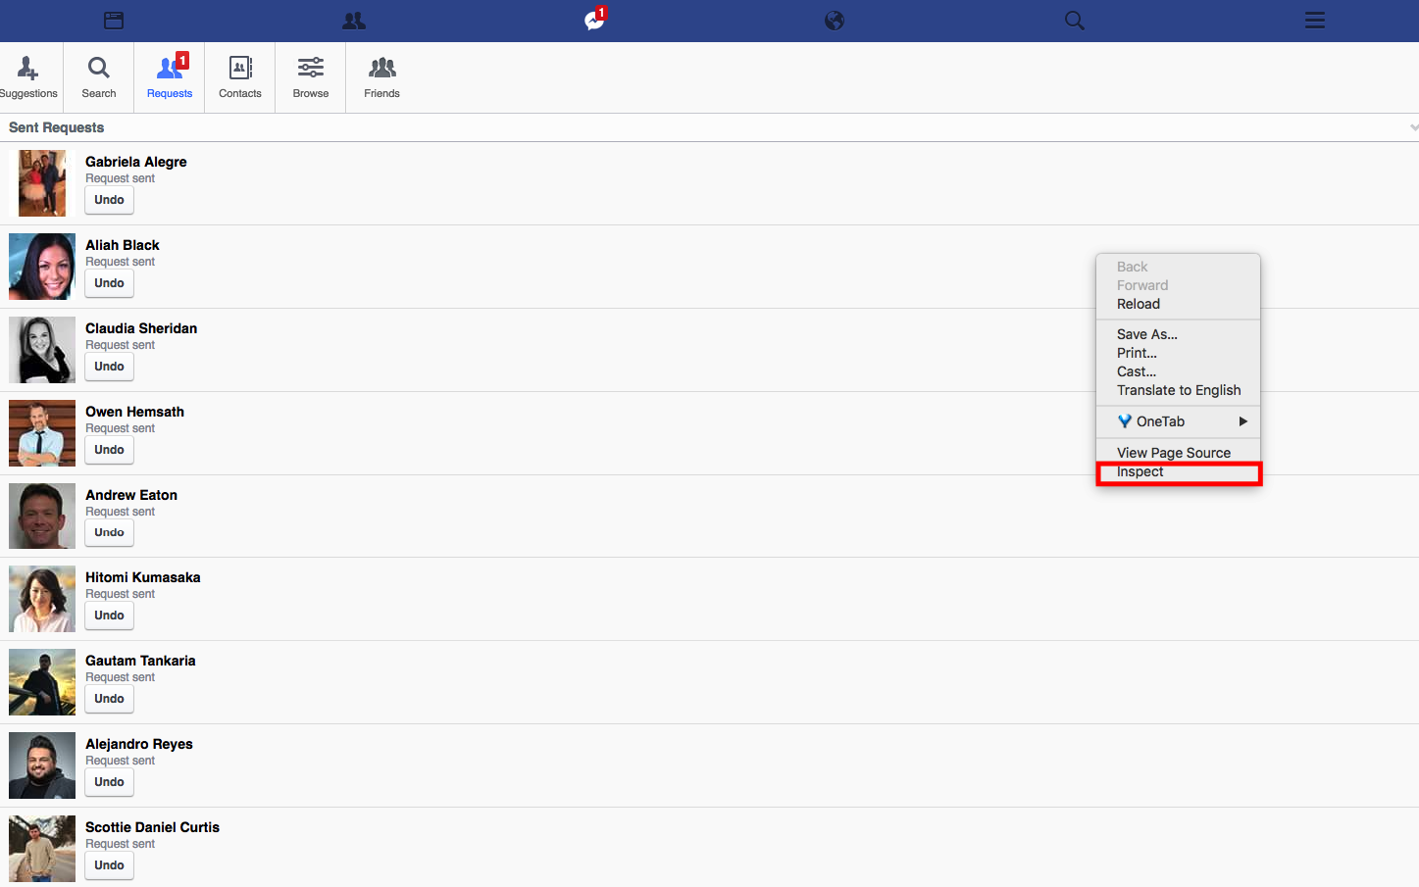

**4. Navigate to ‘Console’**

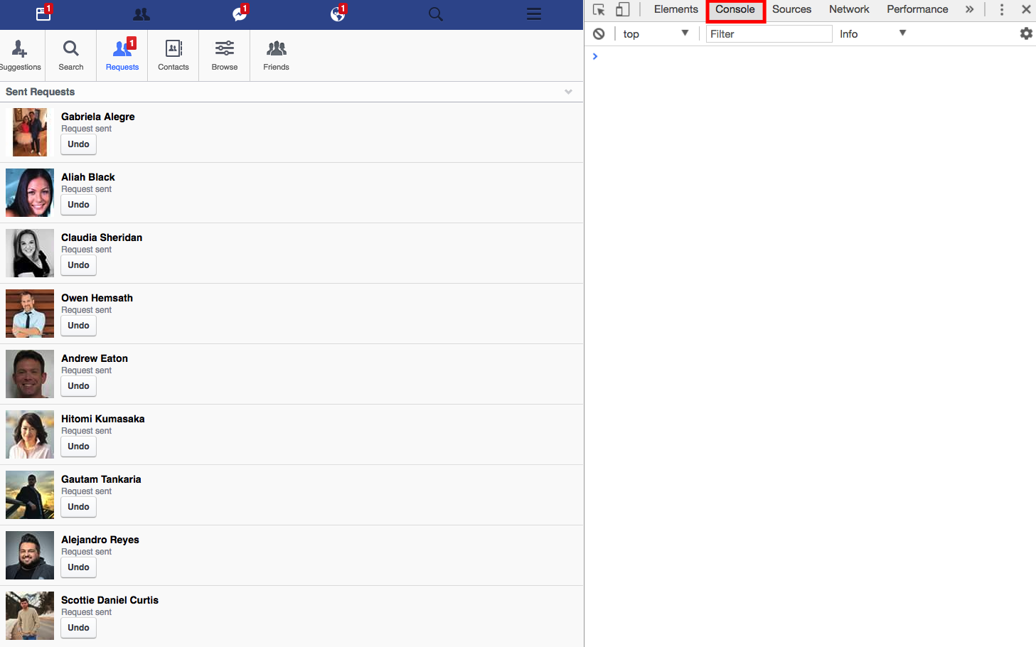

**5. Insert the following code and hit ‘enter’**

|  |
| --- |
| javascript:var inputs = document.getElementsByClassName('_54k8 _56bs _56bt');  for(var i=0; i<inputs.length;i++) {  inputs[i].click();  } |

**6. Done.**